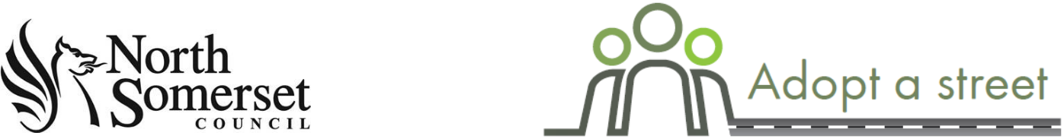

How it works

Adopt a street is your chance to help keep your local area free from litter.

You choose a street or streets that you would like to adopt and then carry out regular litter picks throughout the year, using equipment we provide you with. The aim is to complete a minimum of four litter picks each year.

You can take part as an individual or a group of up to five people. You must be over the age of 18 to join the adopt a street scheme.

Find out more about community litter picking events at www.n-somerset.gov.uk/litterpicks

Please read through and complete this application. Make sure you have read and understood before you apply.

You will then need to read through our adopt a street safety guidelines and complete the safety quiz. These are on the same page of our website at www.n-somerset.gov.uk/adoptastreet.

Application

1. Your details:
Full name:

Telephone number:

Email address:

Emergency contact details:

Name of emergency contact:
Their relationship to you:

Their contact number:

2. Medical declaration
Volunteering for Adopt a street may involve the following activities:

- Some manual handling of refuse bags and recycling boxes.

- Light physical activity e.g. walking around the designated area and picking up items of litter.
- Working on your own.

Would taking part in these activities, within your own limits, increase your risk of injury/ill health above that which you would normally experience on a day to day basis? Yes No

If you answer yes, provide details below. Confirmation from your GP that you can take part in these activities will be required.

Please provide details:

Safety advice:
- If you have an existing medical condition do not work beyond your own capabilities.

- Do not attempt to move or lift anything heavy.

- Only work for short intervals and take breaks.

- If you require medication, ensure you have it on you at all times.

- If necessary, seek medical advice before you start.

- If you feel unwell or short of breath stop work immediately and seek medical advice.

To contact the emergency services, dial 999 if life is in danger or 111 for non-emergencies.

In accordance with data protection this information with be treated as confidential at all times.

3. The street(s) you would like to adopt:
Where you can adopt:

- It must have a speed limit of 30mph or less.

- It must have a pavement or adequate grass verge to keep away from traffic.

- It must not include any significant hazards e.g. cliffs, steep slopes and water bodies.

Street | Town/Parish | Postcode

4. Declaration
I confirm that I am over the age of 18. I have read and understand the risk assessment for litter picking on North Somerset Council Land, and therefore accept my responsibilities as a member of the Adopt a street scheme.

Signed:
If you are completing this form electronically, entering your name in the signed box will act as an electronic signature
Print name:
Date:

Please return completed application to Adopt-a-Street@n-somerset.gov.uk

Next steps

- You now need to read through our adopt a street safety guidelines and complete safety quiz. Once you’ve done that send it to Adopt-a-Street@n-somerset.gov.uk

- After we receive your completed safety quiz, we’ll contact you to arrange for you to get extra bin bags/ recycling boxes, Hi-Viz tabards, gloves and litter pickers.

- If you are an individual litter picker you will need to take the litter collected back home and dispose of it in your kerbside waste/ recycling. If you are a small group, please give us one week’s notice and we can arrange a collection point.

- Tell us if you collect too much waste or there are materials too large for you to remove so we can collect it, please make sure it is clearly visible. You MUST report any waste left at a collection point, otherwise this will be considered as fly tipping and will treated accordingly resulting in the same penalties attached to fly tipping.

- Complete a litter pick log and send it to us after each litter pick and within 30 days. If you carry out more than two litter picks per month you can submit your litter pick log each month.

- Be responsible for the equipment and supplies loaned to you as part of Adopt a street.

- If you are organising a small group litter pick you are responsible for supervising the participating volunteers at all times during the litter pick. You must ensure all participating volunteers have read the safety guidelines, signed and completed the volunteer register and a medical declaration if required. You must also provide all participating volunteers with the relevant PPE (Hi-Viz, gloves, litter pickers) which you can borrow from North Somerset Council. In line with government guidance you must not meet with more than five other people.

Protecting Personal Data

North Somerset Council is registered with the Information Commissioner’s Office for the purposes of processing personal data. The information you provide will be held and used in accordance with the requirements of UK and European data protection law.

