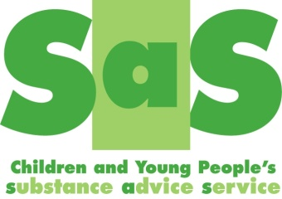

Health and Substance Misuse Referral Form

Referrer’s Name and Organisation

Contact Number |  |  | Date
Where did you hear about us? |  |  | Self/Parental/Carer only:  Did an agency ask you to refer? If so which agency?

Young Persons Details:
Name: |  |  | Date of Birth: |  | Age:
Ethnicity: | Religion: |  | Gender: |  | Language:
Address: |  |  | Contact Numbers:
Consent to send letters home: Yes/No |  |  | Consent to text: Yes/No
With whom do they live:

Are parents/carers aware of the issues:  YES/NO |  | If appropriate Parent/Carers details:
Is their accommodation:  Please give reasons |  | Suitable |  | Unsuitable
Is there a housing issue: |  | Yes |  | No
Preferred contact method:

Dates and times available:

Education or Employment Venue:

Number of ETE hours per week:

Has the young person given consent for this referral? |  | YES  Required |  | NO
Have the parents/carers been informed of this referral? |  | YES  Required for under 13yrs |  | NO

Other agency involvement:

Children’s Social Care involvement Yes/No  Social worker: | Child In Need | Child Protection  Plan | Child Looked After/Care Leaver
Other Professional | Service | Role | Contact details

Please select the Referral Reason:

External Referral |  | Internal Referral (YOS Only)
- Drug and Alcohol Concerns (Required) |  | - General Health
- Smoking Cessation |  | - Mental Health
- Mental Health Concerns |  | - Substance Misuse
- Sexual Health Concerns/Support
- Offending Behaviour
- Child Protection Concerns
- Sexual/Criminal Exploitation Concerns
- Other (please state):

- School Inclusion SAS Intervention
- Youth Alcohol Drug Diversion (YADD) (Police Only)

Summary of problems/concerns
(including drug and alcohol use/mental health/physical health/disability/social circumstance and why the young person wants to be referred)

(Not required if YADD attached)
Summary of risk
(Not required if YADD attached)
Any other relevant information
(Not required if YADD attached)
Is the YP engaged in any therapy or counselling Y/N
If yes, please detail below.
(Not required if YADD attached)
Requirements of order (YOS Only)
(Not required if YADD attached)

Please return the completed form to:
FAO SAS
Young People’s Substance Advice Service, YOS, 24-26 Walliscote Road, WSM, BS23 1UP
Tel: 01275 888360, Fax: 01275 888361
Email: sas@n-somerset.gov.uk

Please do not send referrals to practitioners email addresses.

