|  |
| --- |
| [Company Name or Property Address] |
| Flood Warning & Evacuation Plan |
| Individual or Small Scale (<10) Development |

|  |
| --- |
|  |

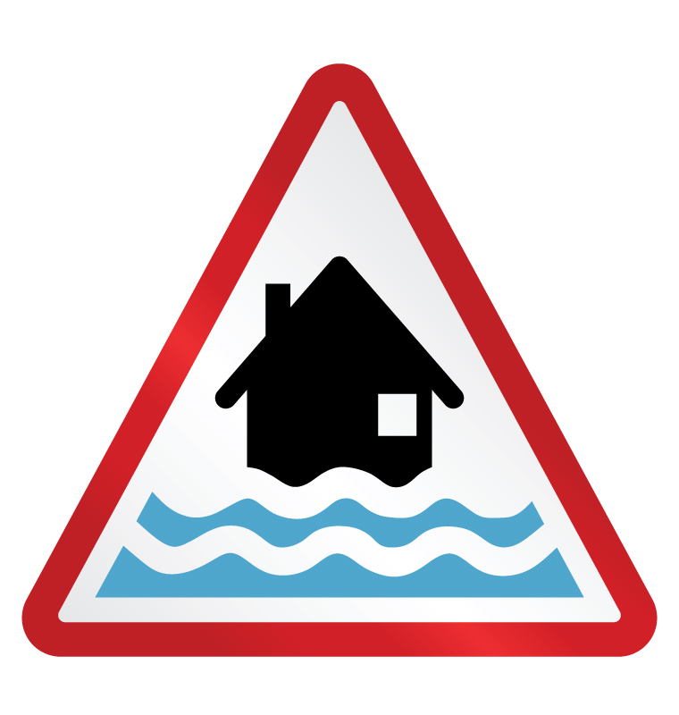

How to Use This Template

This template has been designed to provide an appropriate and proportionate means of flood risk assurance and compliance with current planning regulations.

The template should be made available and completed by the householder whenever the need for a Flood Warning & Evacuation Plan (FWEP) is a condition of the planning application.

# Document Control

This plan is owned, maintained and updated by the householder; whether or not the template was provided by or on behalf of the developer.

It is recommended that the plan is reviewed:

* On first occupation;
* Every 3 years thereafter;
* As a result of lessons learnt;
* Following change of ownership or modification of the premises; or
* Following change to the Flood Warning process.

# Disclaimer

North Somerset Council, as far as it can ascertain, acknowledges that this Flood Warning & Evacuation Plan (FWEP) template is suitable for the purposes set out within the national Planning Policy Framework. This plan is however the sole responsibility of the householder.

North Somerset Council cannot accept responsibility for any omission or error contained in any such plan, or for loss, damage, or inconvenience, which may result from the plans’ implementation. Any subsequent approval does not does not impute any approval of the plans from the Environment Agency or any of the emergency services.

Contents

Document Control i

Disclaimer i

Introduction 1

Property Development company 1

Homeowner 1

Objectives 1

Flood Risk 1

Annex A - Flood Risk Exposure 2

Appendix 1 to Annex A – Flood Risk Map 3

Evacuation 4

Warning & informing 4

Familiarisation 4

Recovery 4

Annex B – Flood Warning Activation Procedures 5

Roles & Responsibilities of Partner Agencies 6

# Introduction

## Property Development company

You are required to provide a copy of this template to property owners and to encourage them to complete the Flood Warning & Evacuation Plan; providing necessary supporting material that should include everything under Flood Risk below.

## Homeowner

If you are the applicant, completion of this template will be a condition of the application. In all cases homeowners are encouraged to complete a FWEP as soon as possible after occupation.

# Objectives

The objectives of this plan are:

* To encourage residents to sign up to [Flood Warnings Direct](https://fwd.environment-agency.gov.uk/app/olr/home) and [Weather Warnings](http://www.metoffice.gov.uk/public/weather/warnings/);
* To ensure homeowners are aware of any residual flood risk;
* That preventative measures are identified to further reduce risk;
* To ensure that occupants receive the necessary flood warnings;
* That occupants respond to flood warnings appropriately; and
* That occupants establish procedures to effect a timely evacuation and place of refuge.

# Flood Risk

Developing a flood response plan is predicated on an understanding of the historical and residual risk, this can be obtained from:

* Historical Flood data (sources of risk), can be obtained from;
  + The developer
  + Environment Agency
  + Local Authority
* A Flood Risk map (no smaller than A4), this can be obtained from;
  + The developer
  + Environment Agency
* Estimated Flood Depth; and frequency / probability; and
* Soft measures to mitigate flood risk.

All of this information can be captured using the template at Annex A.

## Annex A - Flood Risk Exposure

|  |  |  |  |
| --- | --- | --- | --- |
| **Historical Flood Data: (Attach Flood Risk Map as Appendix 1 to Annex A).** | | | |
| **Flood Risk Source:** | **Warning Systems in Place**  **(Flood Warnings Direct etc.)** | **Estimated Flood Depth** | **Frequency / Probability** |
| **Fluvial** |  |  |  |
| **Tidal** |  |  |  |
| **Ground Water** |  |  |  |
| **Surface Water** |  |  |  |
| **Other:** |  |  |  |

### Appendix 1 to Annex A – Flood Risk Map

# Evacuation

The decision to evacuate or take shelter in your property is ultimately for you to make having due regard to the advice/warnings and instructions of the emergency services. Where possible you should make arrangements with family or friends for shelter.

The decision to evacuate must be made to allow sufficient time to conduct the evacuation before flooding occurs. Flood waters contain hidden dangers and will impede if not prevent a safe evacuation.

Where evacuation is not a feasible option, or has been delayed, you should move to the upper floor of the property; taking with you any important documents, bottled water, essential medicines and food sufficient to support you until rescue (see information related to [Grab Bags](https://www.gov.uk/government/publications/preparing-for-emergencies/preparing-for-emergencies)).

You should not assume that the emergency services will be able to assist you with the evacuation; their focus will be directed to those in greatest need.

# Warning & informing

Having signed up to Flood Warnings Direct with the Environment Agency and Weather Warnings from the Meteorological Office, you should utilise Annex B to record your prescribed actions in relation to the flood alert levels.

Annex B provides the means to record your planned actions in relation to the flood alert levels. Alternatively you may wish to make an [emergency plan](https://www.gov.uk/government/publications/preparing-for-emergencies/preparing-for-emergencies) for your home.

Community & Household Resilience

The successful implementation of any plan is dependent on all occupants being familiar with its content and to have rehearsed, where possible, the procedures contained within it. Rehearsing the plan can be made fun and educational for younger members of the family.

Resilience is achieved when individuals and communities cooperate to prepare for, respond to and recovery from emergencies. This begins with engagement with neighbours, understanding your community and culminates in a collective approach to management of risk.

You are encouraged to explore and consider joining Community Resilience North Somerset.

Recovery

If your home is subjected to flooding, and you have evacuated, you may not be allowed to return to your home until it has been declared safe to do so. Your insurance company will provide further guidance and support.

In the event that you did not evacuate it is possible that you will now be encouraged to do so, insurance companies may insist upon it in order to ensure your protection and to effect necessary repairs.

Annex B – Flood Warning Activation Procedures

|  |  |  |  |
| --- | --- | --- | --- |
| **Warnings** | | **EA Recommended Actions** | **Household Actions** |
|  | **What it means:**  Flooding is possible.  Be prepared.  **When it’s used:**  Two hours to two days in advance of flooding. | Be prepared to act on your FWEP.  Prepare a flood kit of essential items.  Monitor [local water levels](http://www.environment-agency.gov.uk/homeandleisure/floods/riverlevels/default.aspx) and the flood forecast on our website. |  |
|  | **What it means:**  Flooding is expected.  Immediate action required.  **When it’s used:**  ½ an hour to one day in advance of flooding. | Move family, pets and valuables to a safe place.  Turn off gas, electricity and water supplies if safe to do so.  Put [flood protection equipment](http://www.environment-agency.gov.uk/homeandleisure/floods/31644.aspx) in place. |  |
|  | **What it means:**  Severe flooding.  Danger to life.  **When it’s used:**  When flooding poses a significant threat to life. | Stay in a safe place with a means of escape.  Be ready should you need to evacuate from your home.  Co-operate with the emergency services.  Call 999 if you are in immediate danger. |  |
| **EA Flood Warnings**  **No longer in force** | **What it means:**  No further flooding is currently expected in your area.  **When it’s used:**  When river or sea conditions begin to return to normal. | Be careful. Flood water may still be around for several days.  If you’ve been flooded, ring your insurance company as soon as possible. |  |
| **Meteorological Office**  **Weather Warnings** | Warnings of heavy rainfall.  Warnings of severe winter weather e.g. hail, snow, freezing rain. | Consider the impact of this type of weather – e.g. this could lead to surface water flooding, ground water flooding, increased river and sea levels. |  |

**SIGN UP TO FLOOD WARNINGS DIRECT**

# Additional Guidance

**Gov.UK:** [Prepare for a Flood](https://www.gov.uk/prepare-for-a-flood/make-a-flood-plan)

**Gov.UK:** [Preparing for Emergencies](https://www.gov.uk/government/publications/preparing-for-emergencies/preparing-for-emergencies)

**Environment Agency:** [Flood Warnings Direct](https://fwd.environment-agency.gov.uk/app/olr/home)

**Meteorological Office:** [Weather Warnings](http://www.metoffice.gov.uk/public/weather/warnings/)

**North Somerset Council:**

[Local Planning Authority](http://www.n-somerset.gov.uk/my-services/planning-building-control/planning/)

[Emergency Management Unit](mailto:emu@n-somerset.gov.uk)